ASG Airlines
Data Engineering & Analytics
Python pipeline • SQLite reporting store • Power BI dashboard

Prepared By,
Reno Reji Matthew
CHRIST(Deemed to be University)

Executive summary
This project converts a four-sheet airline workbook into a reproducible reporting model. It validates flight timestamps and identifiers, preserves unresolved records through explicit quality flags, aggregates payments without multiplying bookings, and replaces passenger identifiers with keyed pseudonyms. Power BI presents duration, route, airline and data-quality analysis across four report pages.
Verified result | Value
Accepted flights | 1,002
Bookings retained | 1,000
Average accepted duration | 164.54 minutes
Overnight flights | 122
Known usable payment amount | 7,385,142.98; currency unspecified
Usable payment-amount coverage | 92.2%
The solution implements a local batch pipeline. Azure services are discussed as a future extension; they are not required to reproduce the current implementation. Observed payment amounts are incomplete and are not established net revenue.

Repository and reading guide
Repository: https://github.com/Reno07Matthew/asg-airlines
Sections 1–7 explain scope, architecture, transformations, privacy, the model and validation. Sections 8–9 provide setup and DAX definitions. Section 10 documents the four dashboard pages with screenshot placeholders. Section 11 records limitations and submission checks.

1. Business problem and scope
The assessment requires a traceable path from imperfect source data to useful airline reporting. The central design choice is to distinguish facts that can be measured from records that require review, while retaining enough evidence to explain every exclusion.
Business question | Implemented approach
How long are flights? | Compute signed elapsed minutes from complete departure and arrival timestamps.
Which routes have the most flights? | Count accepted flight records by directional route.
How does activity differ by airline? | Compare counts and mean duration, retaining UNKNOWN airline labels.
What anomalies affect trust? | Expose invalid duration, conflicting references, unknown status and incomplete amounts.
Can delays or net revenue be reported? | Neither is established by the available source fields.

Source tables and granularity
Worksheet | Rows | Meaning of a source row
flights | 1,020 | A supplied flight record; some are duplicated or conflict.
bookings | 1,000 | A booking with passenger and flight references.
payments | 1,000 | A payment record; several may reference one booking.
passengers | 1,039 | A passenger record; identifiers may repeat with conflicts.
The supplied flight “duration” field is not trusted for analysis. The pipeline recalculates duration from timestamps. Booking data also contains passport and emergency-contact fields; these are excluded from reporting outputs together with direct passenger contact information.

Scope boundaries
Flight departures cover 17–20 April 2026. This supports daily comparison over four days, not seasonality or long-term trend conclusions. The booking date dimension spans 17 April 2025 through 17 April 2026. Passenger counts refer to source identifiers rather than verified distinct people.
The workbook is read as an immutable input. Cleaning operates on copies, with raw values and source-row lineage retained in restricted intermediate data. CSV and SQLite outputs are recreated as full snapshots.

2. Architecture and implementation
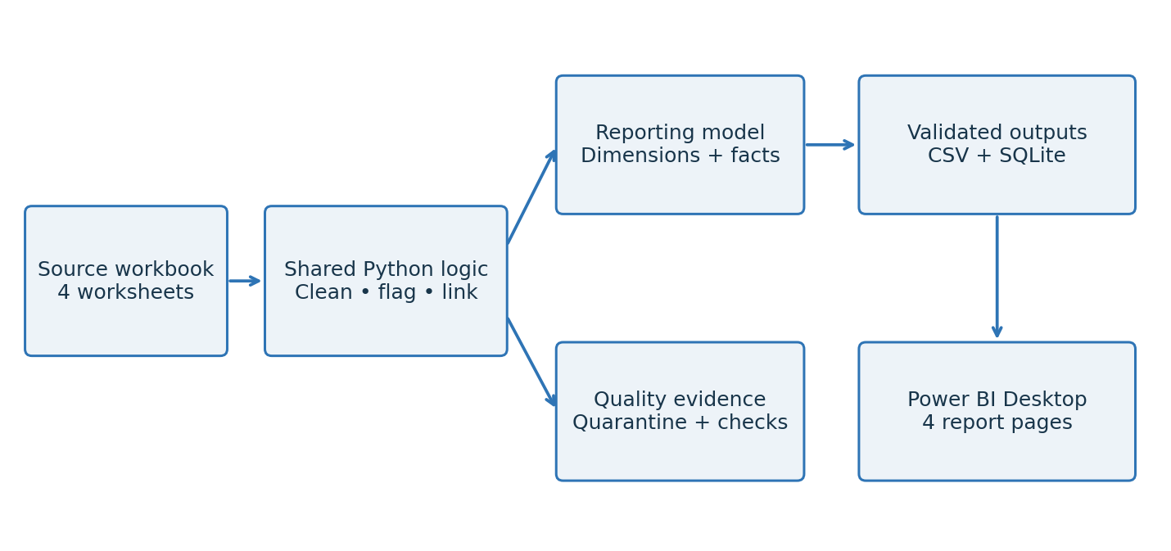
Figure 1. Local data flow. Quality evidence is retained alongside the accepted reporting path. Seven CSV tables feed Power BI; the payment fact remains an audit table.
Module | Responsibility
ingestion.py | Read the workbook and validate the required input structure.
cleaning.py | Normalize labels and IDs; validate timestamps, amounts and references.
privacy.py | Assess repeated passenger IDs and generate stable HMAC tokens.
model.py | Build dimension and fact tables with explicit reporting schemas.
persistence.py | Stage, validate and publish CSV, SQLite and run-summary outputs.
pipeline.py | Expose CLI setup and refresh orchestration.

Shared implementation
The profiling notebook and command-line workflow call the same implementation. This reduces drift between exploratory analysis and repeatable execution. pandas and openpyxl support ingestion and transformation; Python’s standard library supplies Decimal, HMAC, hashing, SQLite and unittest.

Refresh and failure handling
Candidate outputs are staged and validated before publication. CSV/SQLite read-back checks verify values, keys, nulls and monetary totals. SQLite enforces declared constraints. The run summary records execution metadata and output checksums. Repeated refreshes replace snapshots instead of appending duplicates.
Individual file replacements do not make the complete output set atomic. Use one writer and wait for the refresh to complete before importing files. Recovery tests cover failed candidates and interrupted publication, but readers must still avoid mixed snapshots during replacement.

3. Flight quality and duration logic

Normalization and duplicate treatment
Identifiers and airport codes use nullable strings, trimmed whitespace and uppercase normalization. Airline matching ignores case and maps to Air India, IndiGo, SpiceJet and Vistara. Missing and explicit unknown airlines receive the reporting label UNKNOWN, with separate reason flags. Airline names are never inferred from flight-ID prefixes.
The six-airport allowlist and the flight-ID pattern are checks specific to this dataset. They are not universal aviation rules. Exact duplicate copies are removed before identifying remaining conflicting flight IDs.
duration_minutes = (arrival_ts - departure_ts).dt.total_seconds() / 60
The calculation includes complete dates and fractional seconds. It preserves negative values rather than wrapping them into a 24-hour interval. An arrival on a later calendar date is an overnight flag and is allowed when the duration is positive. A common timezone is assumed.
Disposition | Rows | Reason
Duplicate copies removed | 15 | Exact duplicates beyond the retained source record.
Quarantined | 3 | Two conflicting 6F250 records and one invalid SJ192 duration.
Accepted | 1,002 | Records passing the implemented flight checks.
Reconciled source total | 1,020 | 15 + 3 + 1,002.
SJ192 has an arrival date before its departure date and a calculated duration of −1,140 minutes. No speculative 24-hour correction is applied. The two 6F250 records have different origin airports and timestamps; both are quarantined because the identifier does not uniquely identify an authoritative record.
Accepted-flight metric | Result
Mean / median duration | 164.53706 / 166 minutes
Minimum / maximum duration | 30 / 300 minutes
Overnight flights | 122
Missing or unparseable timestamps | 0
Directional routes | 30
Accepted airline counts: Air India 233; IndiGo 249; SpiceJet 235; Vistara 218; UNKNOWN 67. UNKNOWN comprises 39 missing values and 28 explicit unknown labels. Acceptance covers the implemented checks and does not prove operational correctness.

4. Bookings and payment validation

Booking status and references
All 1,000 bookings are retained with unique booking IDs. Normalization preserves original values and parses booking_date into booking_ts. No exact duplicates, missing identifiers or normalization collisions were found.
Status | Bookings | Interpretation
CONFIRMED | 320 | Recognized source status.
CANCELLED | 314 | Observed cancellation share: 31.4% of all bookings.
PENDING | 291 | Recognized source status.
UNKNOWN | 75 | 45 missing and 30 INVALID values; 7.5% of all bookings.
Flight references resolve to 997 accepted flights, two ambiguous references and one quarantined reference. Validated many-to-one left joins preserve every booking. The three unresolved references receive no inferred flight attributes. Booking-after-departure checks pass for 997 rows and remain unknown for three, because departure cannot be established.

Payment arithmetic and coverage
All 1,000 payment IDs are unique and reference an existing booking. The records cover 637 distinct bookings; 267 bookings have multiple payment records. Multiple records are retained and aggregated before joining to bookings, preventing booking multiplication.
Amounts are evaluated with Decimal. There are 48 missing amounts and 30 nonnumeric INVALID values, leaving 922 usable amounts. No supplied amounts were negative, zero or nonfinite. The known total is 7,385,142.98. SQLite stores this exactly as 738,514,298 integer units at scale 100.
Booking-level amount coverage | Bookings
No payment record in this extract | 363
Payment records but no usable amounts | 31
Partial amount coverage | 45
Complete amount coverage | 561
A total remains null when no usable amount exists, which occurs for 394 bookings. Partial coverage retains the known subtotal and its flags. Absence of a record does not establish nonpayment; complete amount coverage does not prove a fare was fully paid. Currency, refunds and settlement status are not established.

5. Passenger privacy and identity conflicts
The passenger worksheet contains 1,039 rows and 1,000 normalized identifiers. Thirty-six repeated-ID groups contain 75 records, or 39 excess rows. None are exact duplicates. All 36 groups contain identity or contact disagreements; choosing the first record would conceal those conflicts.
Field disagreement within repeated IDs | Groups
First name | 11
Last name | 27
Email, phone, Aadhaar and birth date | 36 each
Reported age and gender | 0
The agreed reported age and gender are retained per source identifier only when valid and consistent across its records. The configured age check accepts finite integers from 0 to 120; it is a plausibility check, not identity verification. Ages are not recomputed from birth dates without an authoritative reference date. Thirty-four bookings retain passenger-conflict flags.

Pseudonymization design
HMAC-SHA256 transforms each normalized passenger ID using a persistent 32-byte random secret key. The resulting passenger_token joins bookings to the passenger dimension. Reusing the key keeps tokens stable across refreshes; an evaluator’s new key produces different tokens while preserving linkage inside their own outputs.
Reporting schemas explicitly exclude names, email, phone, Aadhaar, birth date, passport details, emergency contacts and raw passenger IDs. The final passenger dimension retains age bands, gender and quality indicators. Exact reported age remains outside the final dimension.
The key is kept under .secrets/ with restricted Linux permissions: 0700 for its directory and 0600 for the key file. The raw workbook, restricted intermediates and secret must not be included in a public submission. A PBIX import can embed pseudonymized data, so the report still requires appropriate access control.

Analytical interpretation
Age-band counts by source identifier are 215 aged 0–17, 135 aged 18–29, 161 aged 30–44, 169 aged 45–59 and 320 aged 60–120. Gender counts are 527 MALE and 473 FEMALE. These counts do not resolve identity conflicts or establish verified unique people.
This is pseudonymization, not anonymization. Tokens remain linkable, and possession of the secret plus source identifiers enables recomputation. Privacy therefore depends on both schema minimization and controlled access.

6. Reporting model and relationships
Table | Rows | Primary key / grain
DimAirline | 5 | airline_key; one reporting airline
DimRoute | 31 | route_key; 30 routes plus UNRESOLVED
DimFlightDate | 4 | date_key; one departure date
DimBookingDate | 366 | date_key; one booking-calendar date
DimPassenger | 1,000 | passenger_token; one source identifier
FactFlights | 1,002 | flight_id; one accepted flight
FactBookings | 1,000 | booking_id; one booking
FactPayments | 1,000 | payment_id; one payment audit record
Import the five dimensions, FactFlights and FactBookings into the initial Power BI model. FactPayments is an audit output; its payment totals are already aggregated into FactBookings for the report.
One side | Many side | Join column on fact
DimAirline[airline_key] | FactFlights and FactBookings | airline_key
DimRoute[route_key] | FactFlights and FactBookings | route_key
DimFlightDate[date_key] | FactFlights and FactBookings | flight_date_key
DimBookingDate[date_key] | FactBookings | booking_date_key
DimPassenger[passenger_token] | FactBookings | passenger_token
These are eight active, one-to-many, single-direction relationships, filtering from dimension to fact. Do not add a direct FactFlights–FactBookings relationship to this design. Shared dimensions filter both facts, while booking date and passenger filters affect bookings only.
Airline key 0 means UNKNOWN. Route key 0 means UNRESOLVED. The three unresolved bookings keep null flight-date keys and explicit reference-status flags. Filtering to a known route or flight date can exclude them; overall booking totals retain them.
CSV monetary columns should use Fixed Decimal Number in Power BI. IDs and tokens are Text, keys and 0/1 flags are Whole Number, durations are Decimal Number, timestamps are Date/Time and calendar dates are Date. Preserve nulls. The detailed field-by-field dictionary is maintained in docs/reporting_model.md.

6.1 Model screenshot
Insert the Power BI Model view after verifying the eight relationships listed on the previous page. Arrange dimensions above the two fact tables so filter direction is easy to inspect.
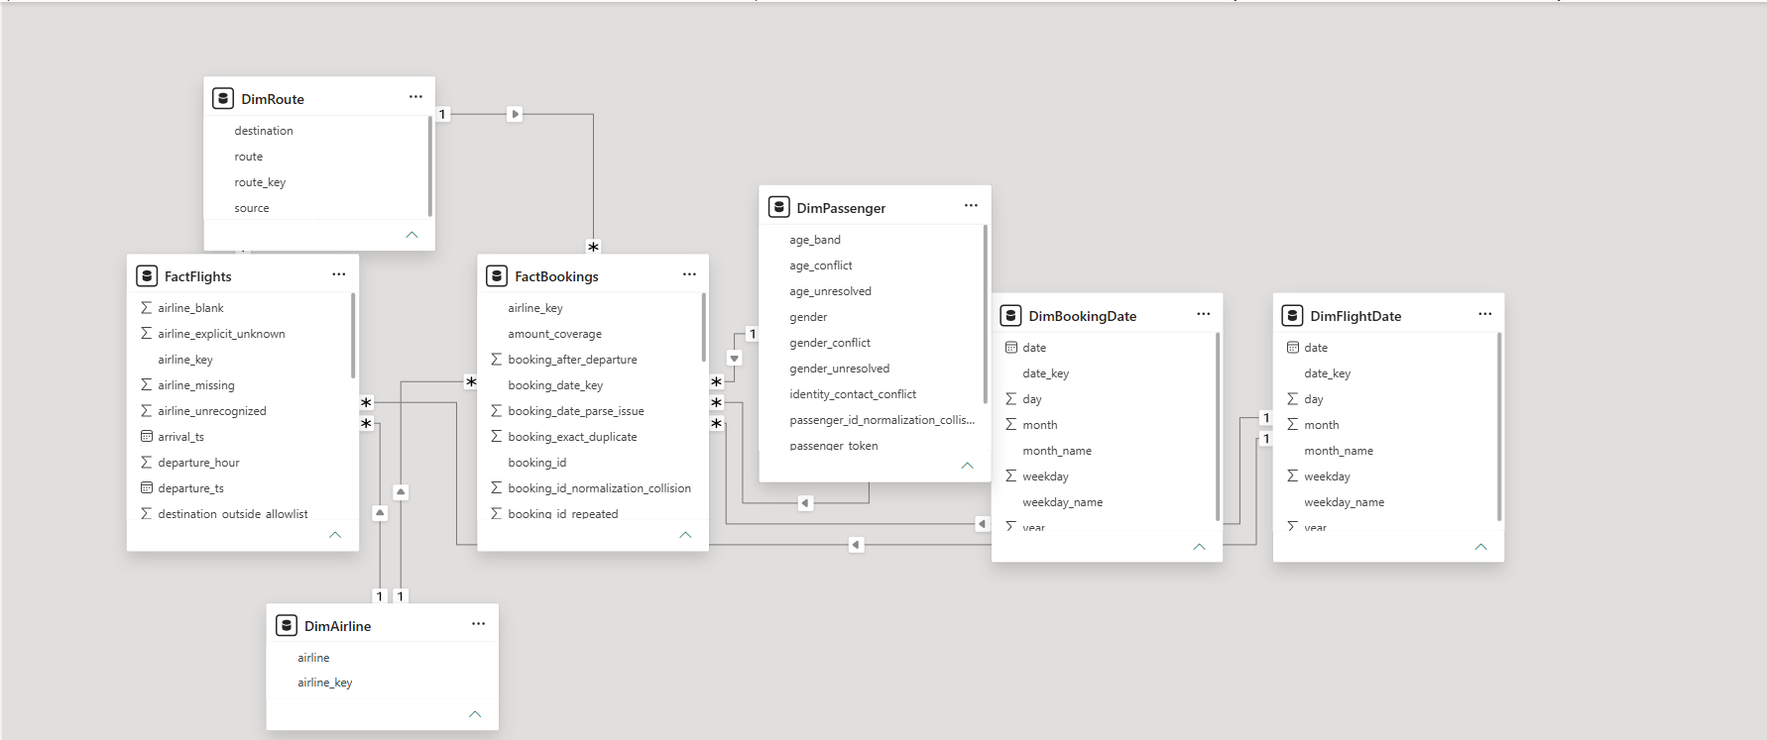

What this screenshot should show
The five dimensions, two facts, one-to-many markers and active relationships should be visible. The payment audit table does not need to appear. Use Manage relationships separately if the diagram does not make the cardinality or direction readable.

Refresh semantics
Dimension keys are generated deterministically for the current full snapshot. New labels may change their assignment on later snapshots. An incremental implementation would need persistent key management instead of assuming these keys remain stable across evolving datasets.

7. Validation and audit evidence
Validation checks go beyond matching record counts. They verify row identities, raw-value preservation, referential integrity, null behavior and arithmetic reconciliation. Source checksums detect unintended input changes.
Check | Observed result
Flight disposition reconciliation | 15 duplicate copies + 3 quarantined + 1,002 accepted = 1,020.
Booking retention | 1,000 unique bookings; validated joins add no rows.
Monetary reconciliation | Transaction and booking totals both equal 7,385,142.98.
Missing-amount preservation | 78 unusable transactions and 394 null booking subtotals.
Output integrity | CSV/SQLite read-back, primary keys and foreign keys checked.
Synthetic test suite | Nine tests passed during repository review.
Supplied-workbook regression | Passed with a temporary valid key setup and the supplied workbook.

Review qualification
The secret-exclusion ordering issue was corrected. .secrets/ is now the last active rule in .gitignore, satisfying the current key-setup requirement.
The report file and its four page definitions were inspected. This review does not replace opening the PBIX in Power BI Desktop, checking refresh paths and confirming the rendered measures. The final screenshots should come from the completed Desktop report.

Audit metadata
data/processed/run_summary.json records the refresh result, source fingerprint, output row counts, quality metrics and output fingerprints. These records support comparison between runs without publishing the secret or direct passenger information.

Meaningful test coverage
The test suite covers synthetic quality and linkage cases, exact payment handling, safe output publication and interrupted-publication recovery. The supplied-workbook regression separately checks the expected dataset totals. This separation avoids treating hardcoded sample counts as general cleaning rules.

8. Reproduce the project
Run the pipeline on Linux from the project root. The existing workflow uses a Python virtual environment and requirements.txt. SQLite must support STRICT tables (version 3.37 or later). Windows is used for Power BI Desktop; native Windows execution of the key-permission code is not assumed.

1. Prepare dependencies and input
python -m venv .venv
.venv/bin/python -m pip install -r requirements.txt
Place the supplied workbook at data/raw/UseCase - Airlines.xlsx. Keep the original workbook unchanged and excluded from public Git tracking.

2. Check the secret exclusion before setup
Move the existing .secrets/ rule to the bottom of .gitignore so it is the last nonblank, noncomment rule. Preserve the other exclusions. This is required by the current privacy.py setup guard.
# Last active line in .gitignore:
.secrets/
Initialize a key only in a fresh environment. Reuse an existing valid key; do not regenerate it for an ordinary refresh.
.venv/bin/python -m src.pipeline --init-key \
--key-file .secrets/passenger_hmac.key

3. Generate and verify the reporting snapshot
.venv/bin/python -m src.pipeline \
--input "data/raw/UseCase - Airlines.xlsx" \
--output-dir data/processed \
--key-file .secrets/passenger_hmac.key
.venv/bin/python -m unittest discover -s tests -p 'test_*.py' -v
.venv/bin/python -m tests.check_sample
The notebook is notebooks/01_data_profiling.ipynb. Run its cells in order using the same environment. Do not run Python with optimization enabled, because assertions form part of the validation contract.

4. Open Power BI
Transfer the completed CSV snapshot to Windows. Open ASG_Airlines_Operations.pbix and update its CSV source locations in Power Query Data source settings. Refresh, confirm data types, verify the eight relationships and save the PBIX. The existing imported report can open without the original Linux paths, but refreshing requires accessible files.

9. KPI definitions and DAX
Create each expression as a separate measure. Define Total Flights and Total Bookings first, because other measures reference them. Percentage formatting changes display; it does not divide a count by its denominator.
Total Flights = COUNTROWS(FactFlights)
Average Duration Minutes = AVERAGE(FactFlights[duration_minutes])
Overnight Flights =
CALCULATE([Total Flights], FactFlights[is_overnight] = 1)
Total Bookings = COUNTROWS(FactBookings)
Known Payment Amount = SUM(FactBookings[known_payment_amount])
Usable Amount Coverage =
DIVIDE(
SUM(FactBookings[usable_amount_count]),
SUM(FactBookings[payment_record_count])
)
Unknown Status Bookings =
CALCULATE(
[Total Bookings],
KEEPFILTERS(FactBookings[status] = "UNKNOWN")
)
Unresolved Flight Bookings =
CALCULATE(
[Total Bookings],
KEEPFILTERS(FactBookings[flight_reference_status] <> "accepted")
)
Measure | Unfiltered checkpoint | Display
Total Flights / Total Bookings | 1,002 / 1,000 | Whole number
Average Duration Minutes | 164.54 | Two decimal places
Overnight Flights | 122 | Whole number
Known Payment Amount | 7,385,142.98 | Two decimals; no currency symbol
Usable Amount Coverage | 92.2% | Percentage; one decimal
Unknown / Unresolved Bookings | 75 / 3 | Whole number
Coverage is 922 usable payment records divided by 1,000 payment records, not the percentage of fully paid bookings. Keep counts as counts. Use KEEPFILTERS for status measures so a conflicting status selection is respected rather than silently replaced.

10.1 Dashboard: Duration Analysis
Purpose: summarize accepted flight duration and show differences among reporting airlines. The page includes Total Flights, Average Duration Minutes and Overnight Flights, a bar chart of mean duration by airline, and an airline slicer.
Visual | Fields
KPI indicators | Total Flights; Average Duration Minutes; Overnight Flights
Horizontal bar chart | Category: DimAirline[airline]; value: Average Duration Minutes
Slicer | DimAirline[airline]
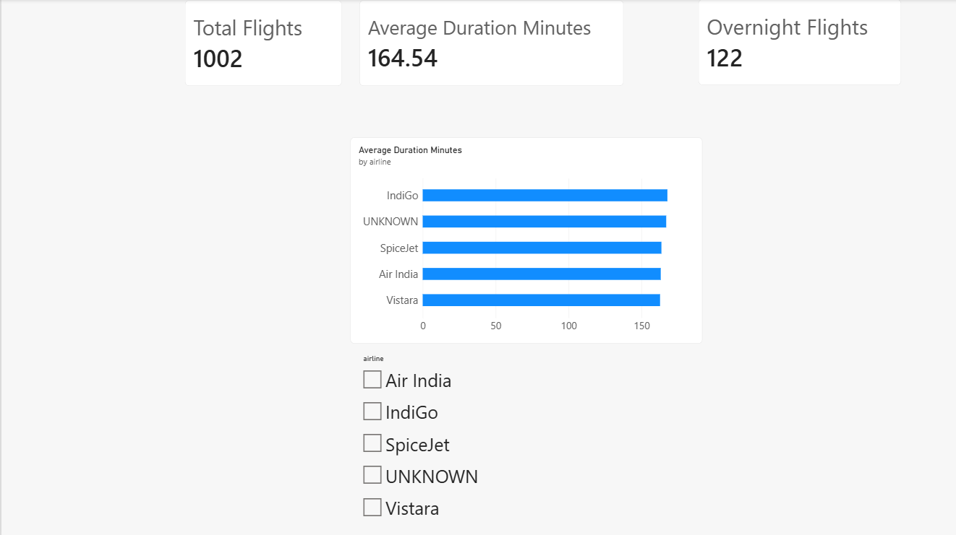
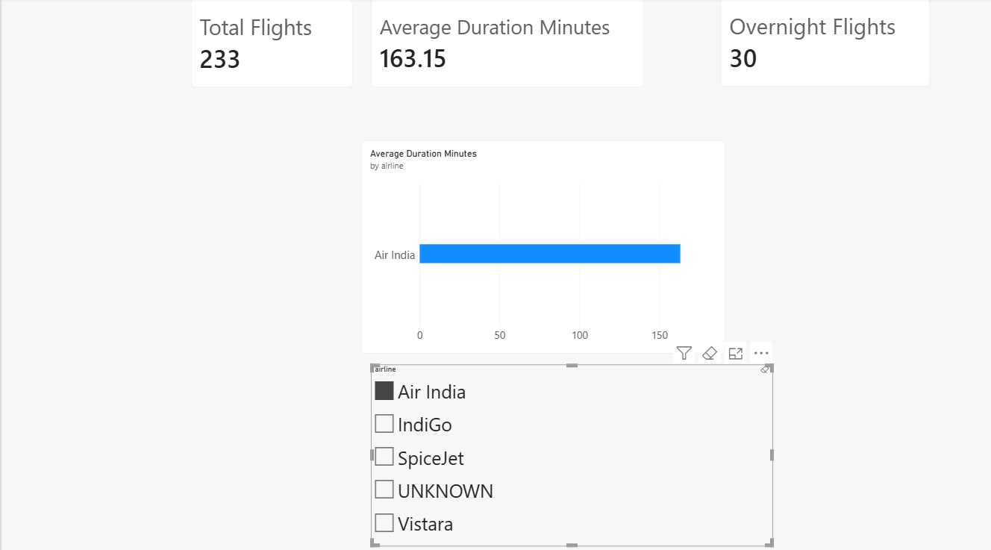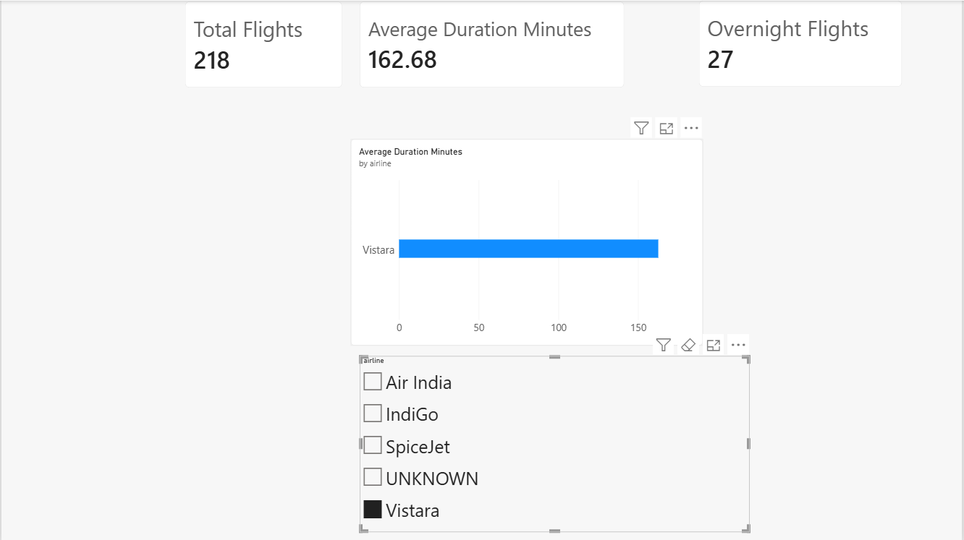

Interpretation: mean duration depends on route mix and the supplied schedule. A longer mean is not evidence of worse punctuality. Overnight flights are valid records, not automatically anomalies.

10.2 Dashboard: Route Performance
Purpose: identify the busiest directional routes in the accepted-flight extract and compare average elapsed duration. The page includes a route count bar chart, a route summary table and an airline slicer.
Visual | Fields
Route bar chart | DimRoute[route] and Total Flights; descending Top 10 by Total Flights
Summary table | DimRoute[route], Average Duration Minutes, Total Flights
Slicer | DimAirline[airline]
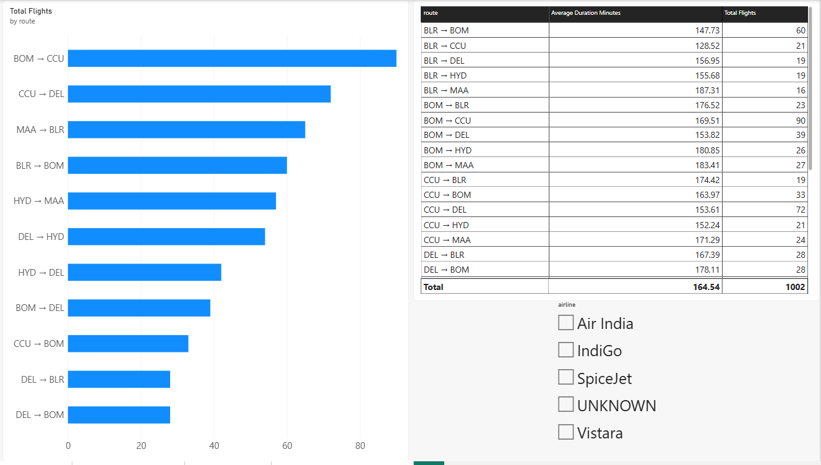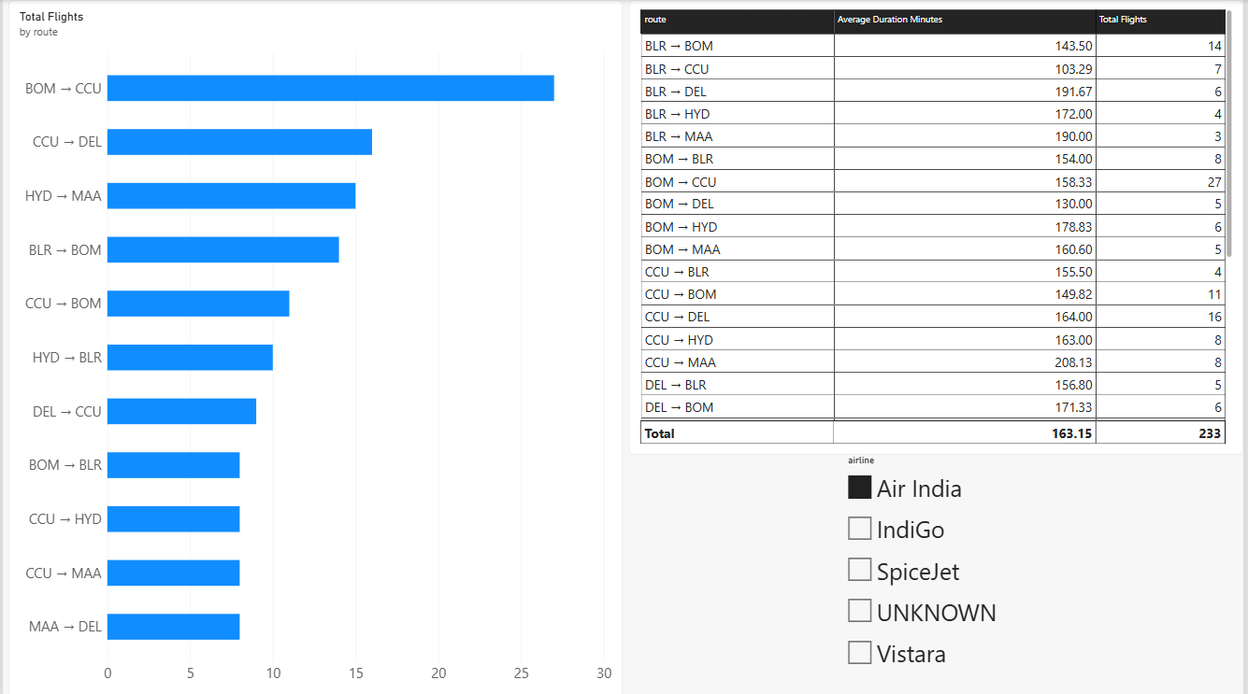

Flight counts and mean duration by directional route. Clear the airline slicer when comparing against the overall checkpoints.
Unfiltered busiest routes: BOM → CCU has 90 flights, CCU → DEL has 72 and MAA → BLR has 65. The extract contains 30 directional routes. BLR → BOM and BOM → BLR are separate categories. These counts describe accepted flight records, not passenger demand or seat occupancy.

10.3 Dashboard: Airline Trends
Purpose: compare airline flight counts and daily activity during the four-day departure window. The page includes an airline count column chart and a daily line chart with airline as the legend.
Visual | Fields
Column chart | DimAirline[airline] and Total Flights
Daily line chart | DimFlightDate[date], Total Flights, legend: DimAirline[airline]
Context note | Departure dates: 17–20 April 2026; limited observation period.
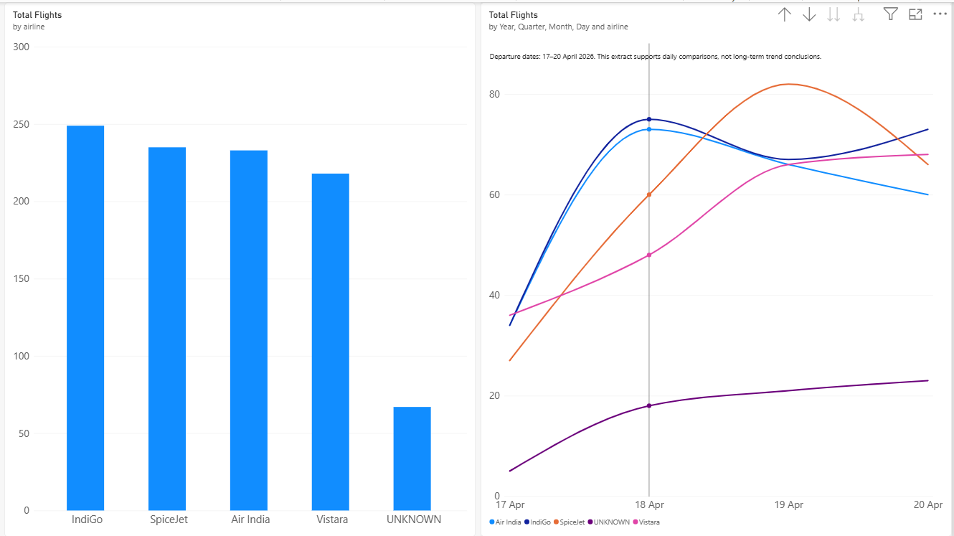
Airline distribution and daily flight counts within the available departure window. Prefer the plain date field, or ensure the date hierarchy is displayed at day level.
Checkpoints: IndiGo 249, SpiceJet 235, Air India 233, Vistara 218 and UNKNOWN 67. UNKNOWN remains visible to avoid overstating airline completeness. Use straight lines and visible daily points where possible; interpolation between four dates should not imply additional observations.

10.4 Dashboard: Data Quality and Payments
Purpose: make missing information and unresolved references visible beside the booking and payment totals. The page includes five KPI indicators, bookings by status, booking-level amount coverage and an explanatory quality note.
Indicator | Unfiltered value
Total Bookings | 1,000
Known Payment Amount | 7,385,142.98; no currency symbol
Usable Amount Coverage | 92.2%
Unknown Status Bookings | 75
Unresolved Flight Bookings | 3
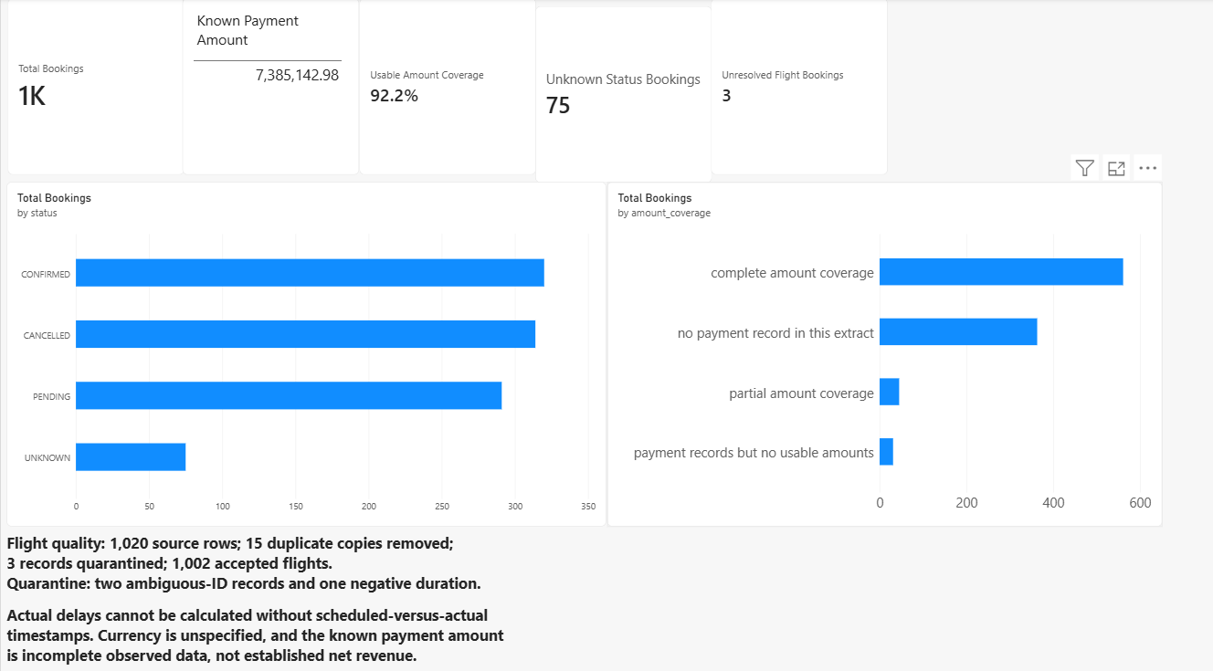
Booking quality, known payment amounts and amount completeness. Confirm the percentage is 92.2%, not a formatted raw count, and remove any inferred currency symbol.
Status chart checkpoints are 320 confirmed, 314 cancelled, 291 pending and 75 unknown. The page note should state that actual delays cannot be calculated and that known amounts are incomplete observed data, not established net revenue.

11. Limitations, scalability and submission

Current limitations
The workflow processes an in-memory workbook snapshot. It is not a streaming system or a deployed Azure solution, as due to my time constraint of submitting it by the time. But it will hosted later in the mean time.

Future extension
A larger implementation could retain immutable source files in cloud object storage, orchestrate ingestion, and separate raw, validated and reporting layers. Partitioned columnar files and a distributed transformation engine could replace workbook-wide in-memory processing. A managed secret store and access controls could replace local key storage. These are proposed enhancements, not implemented project features.
Incremental loads would also require persistent surrogate-key mapping, change detection, versioned schemas and a consistent publication boundary. Quality metrics should be monitored per batch, with thresholds and explicit remediation ownership. SQLite remains appropriate for the supplied assessment scale but has a single-writer constraint.

Appendix. Repository evidence and terminology

Where to find implementation details
Topic | Primary project reference
Input schema and loading | src/ingestion.py
Cleaning and quality rules | src/cleaning.py
Passenger agreement and secret handling | src/privacy.py
Reporting columns and relationships | src/model.py; docs/reporting_model.md
CSV, SQLite and refresh behavior | src/persistence.py
CLI entry point | src/pipeline.py
Worked profiling narrative | notebooks/01_data_profiling.ipynb
Synthetic and sample checks | tests/test_pipeline.py; tests/check_sample.py
User setup and limitations | README.md

